**DAILY ONLINE ACTIVITIES SUMMARY**

|  |  |  |  |  |  |  |  |  |
| --- | --- | --- | --- | --- | --- | --- | --- | --- |
| **Date:** | **28-05-2020** | | | | | **Name:** | **Latika Kavoor** | |
| **Sem & Sec** | **4th Sem & A-Section** | | | | | **USN:** | **4AL18CS035** | |
| **Online Test Summary** | | | | | | | | |
| **Subject** | | 1. **MES** 2. **VYAVAHARIKA KANNADA** | | | | | | |
| **Max. Marks** | | 1. **20** 2. **50** | | **Score** | | | 1. **17** 2. **47** | |
| **Certification Course Summary** | | | | | | | | |
| **Course** | **Introduction to Cyber Security** | | | | | | | |
| **Certificate Provider** | | | **ICT Academy - CISCO** | | **Duration** | | | **30 hrs** |
| **Coding Challenges** | | | | | | | | |
| **Problem Statement:** C program to find digital root of a number. | | | | | | | | |
| **Status: Completed** | | | | | | | | |
| **Uploaded the report in Github** | | | | | **Yes** | | | |
| **If yes Repository name** | | | | | <https://github.com/alvas-education-foundation/latika.kavoor/tree/master/coding_solutions> | | | |
| **Uploaded the report in slack** | | | | | **Yes** | | | |

Online Test Details: (Attach the snapshot and briefly write the report for the same)

MES IA2 test was conducted online from 12:00pm for 20 marks.

One more test was conducted on Vyavaharika Kannada from 2:00pm to 2:50pm for 50 marks.

MES TEST2

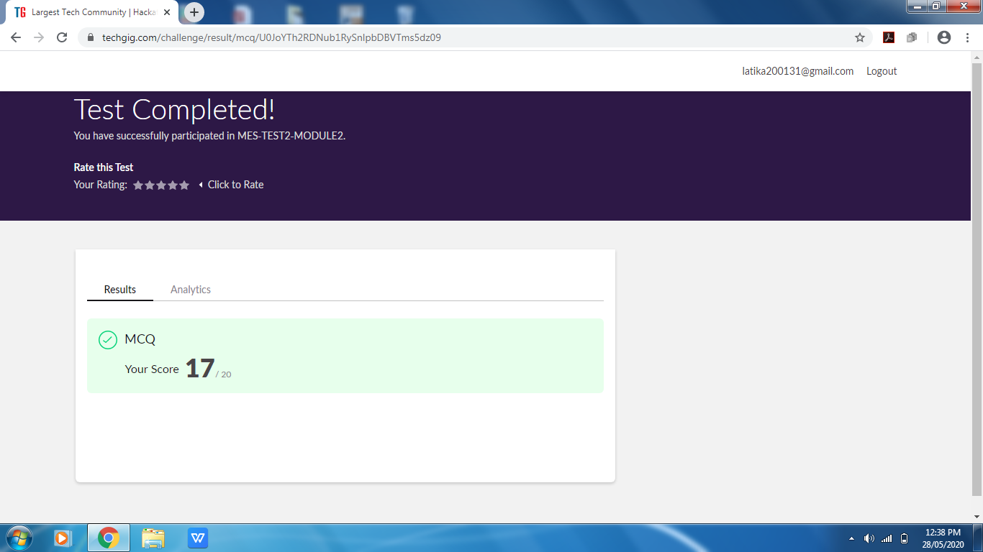

VYAVAHARIKA KANNADA

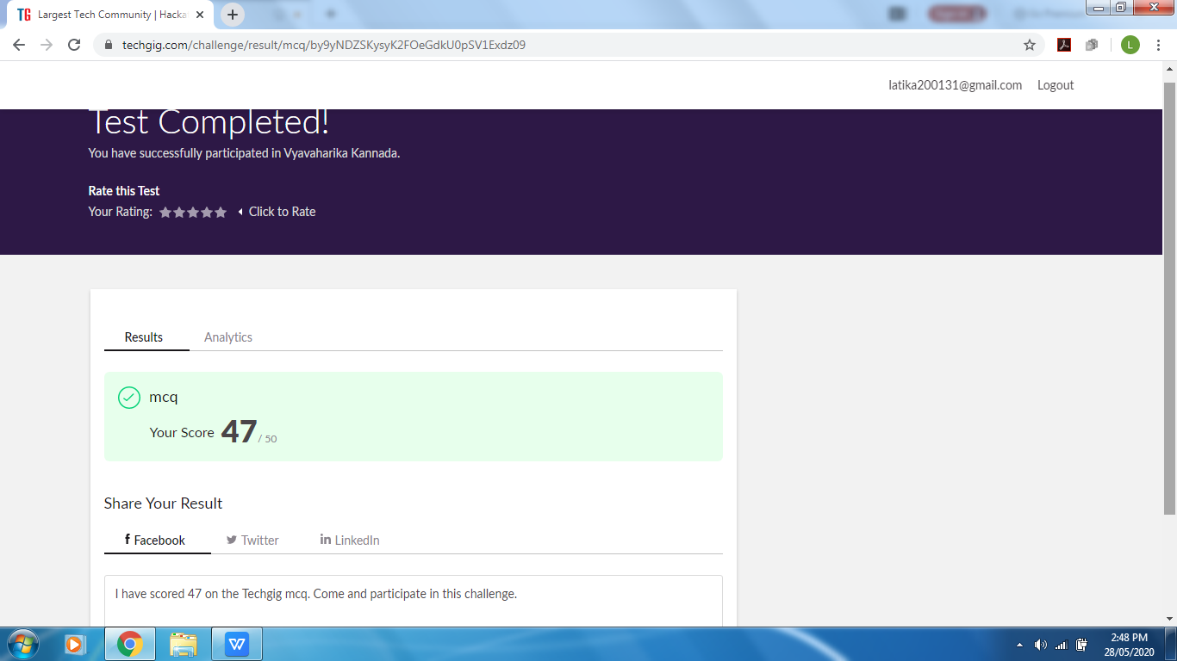

Certification Course Details: (Attach the snapshot and briefly write the report for the same)

Completed with the cybersecurity essential course provided by ICT Academy and Cisco. I had solved all the Quiz for the same before and got the certificate of it on 26-05-2020.

Futher are the details of the course and the certificate.

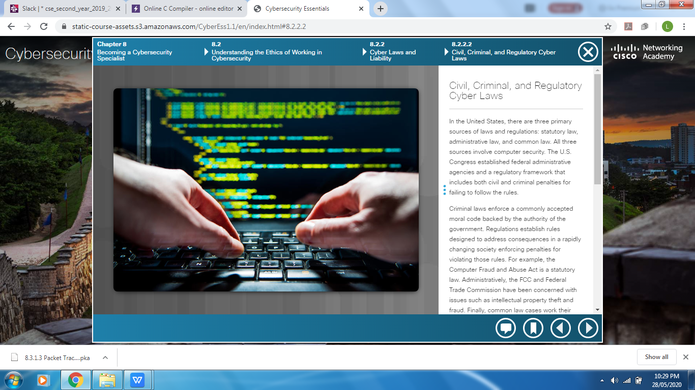

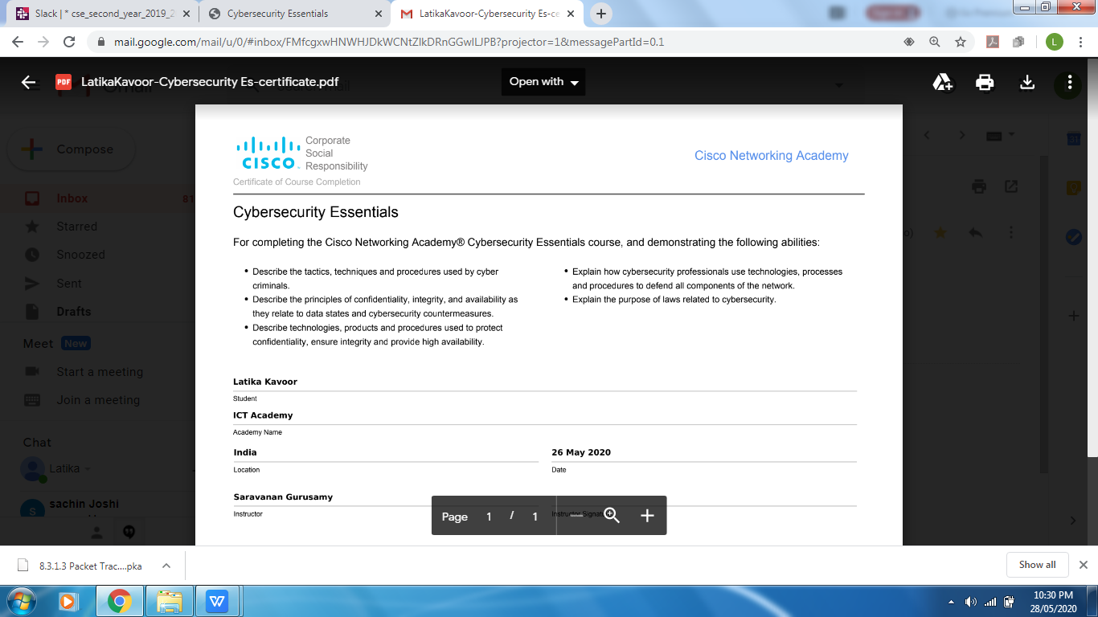

Coding Challenges Details: (Attach the snapshot and briefly write the report for the same)

Solved problem and uploaded it on github

